ERD Diagram
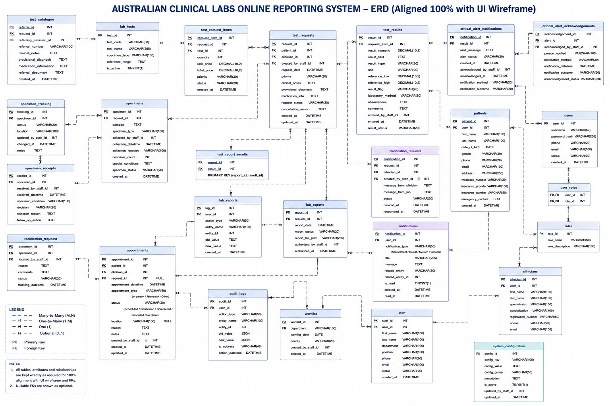
FR | Functional Requirement | ERD Table(s) | Key Field / Data | Status
FR1 | User Registration | users, patients, clinicians, staff | user_id, username, email, password_hash | Supported
FR2 | User Authentication | users | username, password_hash, status | Supported
FR3 | Multi-Factor Authentication | users, system_configuration | user_id, security configuration settings | Partially Supported
FR4 | Role-Based Access Control | users, user_roles, roles | user_id, role_id | Supported
FR5 | User Account Management | users, audit_logs | status, created_at, action_type | Supported
FR6 | User Profile Management | users, patients, clinicians, staff, notifications | contact details, profile details, notification data | Supported
FR7 | Patient Registration | patients, users | patient_id, date_of_birth, Medicare, insurance, emergency_contact | Supported
FR8 | Patient Identity Verification | patients | patient_id, first_name, last_name, date_of_birth | Supported
FR9 | Patient Record Search | patients, test_catalogue | name, date_of_birth, phone, referral_number | Supported
FR10 | Duplicate Patient Detection | patients | patient_id, name, date_of_birth, phone | Supported by Application Logic
FR11 | Laboratory Test Catalogue | lab_tests, system_configuration | test_code, test_name, specimen_type, reference_range | Supported
FR12 | Test Request Creation | test_requests, test_request_items | request_id, patient_id, clinician_id | Supported
FR13 | Electronic Referral Management | test_catalogue, test_requests | referral_number, clinical_notes, provisional_diagnosis, medication_info | Supported
FR14 | Test Request Validation | test_requests, test_request_items | mandatory request and test fields | Supported by Application Logic
FR15 | Test Request Priority | test_requests, test_request_items | priority | Supported
FR16 | Test Request Modification / Cancellation | test_requests, audit_logs | request_status, cancellation_reason, audit data | Supported
FR17 | Specimen Registration | specimens | specimen_id, request_id | Supported
FR18 | Barcode Generation | specimens | barcode | Supported
FR19 | Specimen Label Printing | specimens, patients | barcode, specimen_type, patient identifiers | Supported
FR20 | Specimen Collection Recording | specimens | collection_datetime, collection_location, collected_by_staff_id, container_count | Supported
FR21 | Specimen Tracking | specimen_tracking, specimens | status, location, changed_datetime | Supported
FR22 | Specimen Receipt | specimen_receipts | received_by_staff_id, received_datetime, specimen_condition | Supported
FR23 | Specimen Acceptance / Rejection | specimen_receipts | decision, rejection_reason, follow_up_action | Supported
FR24 | Specimen Recollection | recollection_requests | specimen_id, reason, status | Supported
FR25 | Laboratory Worklist | worklist, specimens, test_request_items | department, worklist_date, priority | Supported
FR26 | Test Assignment | worklist, staff | department, created_by_staff_id | Partially Supported
FR27 | Test Result Entry | test_results | result_numeric, result_text, unit, laboratory_method, observations, comments | Supported
FR28 | Automated Result Import | test_results | result fields and laboratory method | Partially Supported
FR29 | Result Validation Rules | test_results, lab_tests, system_configuration | reference_low, reference_high, unit, configuration values | Supported
FR30 | Abnormal Result Identification | test_results | result_flag, reference_low, reference_high | Supported
FR31 | Critical Result Alerts | critical_alert_notifications, test_results | result_id, alert_status, alert_message | Supported
FR32 | Critical Result Acknowledgement | critical_alert_acknowledgements | acknowledged_by_staff_id, person_notified, notification_method, outcome, status | Supported
FR33 | Result Review | test_results, test_requests, patients | results, clinical notes, patient and request information | Supported
FR34 | Result Correction | test_results, audit_logs | old_value, new_value, user_id, action_datetime | Supported
FR35 | Result Authorisation | lab_reports, staff, roles | authorized_by_staff_id, authorized_at | Supported
FR36 | Clinical Comment Management | test_results, lab_reports | comments and report data | Supported
FR37 | Laboratory Report Generation | lab_reports, test_report_results, test_results | report_id, result_id, report_status, report_file_path | Supported
FR38 | Preliminary / Final Reports | lab_reports | report_status | Supported
FR39 | Report Distribution | lab_reports, notifications, users | report_file_path, notification data, user_id | Supported
FR40 | Clinician Portal | clinicians, test_requests, test_results, lab_reports, critical_alert_acknowledgements, clarification_requests | clinician workflow data | Supported
FR41 | Patient Portal | patients, appointments, test_payment, lab_reports, notifications | appointment, payment, report and notification data | Supported
FR42 | Result History and Trends | test_results, test_request_items, patients | historical test result records | Supported
FR43 | Notification Management | notifications, critical_alert_notifications | notification_type, title, message, is_read | Supported
FR44 | Audit Trail | audit_logs | user_id, action_type, entity_name, entity_id, old_value, new_value, ip_address, action_datetime | Supported
FR45 | Laboratory Reporting and Analytics | operational tables, audit_logs | test, result, specimen, status and workload data | Supported by Application Logic
FR46 | System Configuration Management | system_configuration, lab_tests, roles | config_key, config_value, config_group, test and role configuration | Supported
FR47 | Compliance | users, roles, user_roles, audit_logs, system_configuration | access control, audit and configuration data | Supported by Application Logic
Status Notes
Supported: The ERD contains the required entities and data fields to directly support the functional requirement.
Partially Supported: The ERD contains relevant data structures, but additional backend logic, integration, or implementation is required to fully deliver the function.
Supported by Application Logic: The ERD stores the necessary data, while the main behaviour is implemented through application or business logic rather than through an additional dedicated database table.
Note: A database ERD represents persistent data structures and relationships. Some functional requirements, such as validation, duplicate detection, automated imports, analytics, security enforcement and compliance controls, also depend on application logic and system configuration.

